**Sprint 3 Review**

**Meme Feed**

**Meme Teme**

**2/26/19**

**Revision 0**

* Actions to Stop Doing
  + Stop discussing technical details during Scrum meetings
  + Stop having vague tasks
* Actions to Start Doing
  + Start componentizing things more
  + Start merging after every completed task
  + Finishing tasks and user stories
  + Start thinking about the tasks when creating them and make them really specific
  + Start bringing Post-Its to Sprint Plan meetings
* Actions to Keep Doing
  + Keep doing a good job! (on things like UI)
  + Keep communicating like we are
  + Keep working together
  + Keep bringing snacks to meetings
* Work Completed/Not Completed
  + About 91% tasks completed
  + Not Completed:
    - User Story: (1) As a user, I want to be able to see a Friend Feed which displays memes my friends liked. **(14)**
      * Task: Pull memes from firebase that the user’s friends have liked and sort them in chronological order. **(6)** *(Zac)*
    - User Story: (4) As a User, I want to be able search and look up someone else’s page, to see only their content **(16)**
      * Task: Implement the firebase functionality of the search typing a name and the results appearing in the search results. **(9)** *(Jon)*
* Work Completion Rate
  + Sprint 1: 1 user stories completed, 20 total ideal hours completed across 14 days
    - Stories/day : 0.7
    - Ideal work hours / day: 1.4
  + Sprint 2: 5 user stories completed, 53 total ideal hours completed across 14 days
    - Stories/day : 0.36
    - Ideal work hours / day: 3.79
  + Sprint 3: 5 user stories completed, 65 total ideal hours completed across 14 days
    - Stories/day: 0.36
    - Ideal work hours / day: 4.64
  + All Sprints: 11 user stories completed, 138 total ideal hours completed across 42 days
    - Stories/day : 0.26
    - Ideal work hours / day: 3.29

**Final Burnup Chart:**

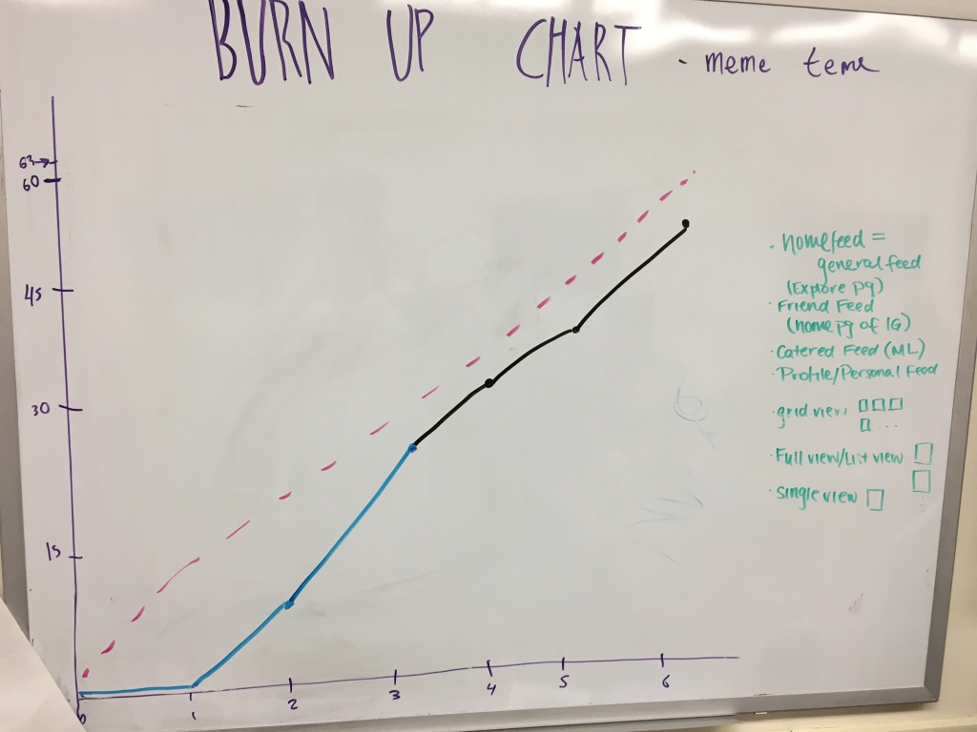

**Final Scrum Board:**

